VOLUNTEER HOURS VERIFICATION
@CREATIVITY THINK (9483175986/7019689991)

ABSTRACT:
Volunteer Hours Verification is a web-based system designed to streamline the process of logging, approving, and tracking volunteer hours for NGOs, student internships, and clubs. The platform allows users to submit their volunteer hours, obtain supervisor sign-off, and monitor progress via a dashboard. Administrators can review submissions, approve hours, track overall participation, and generate feedback and analytical reports. Developed using Django and Django Rest Framework for backend operations, and React with Redux and recharts for the frontend, the system provides a secure, efficient, and transparent framework for volunteer hour management..

INTRODUCTION OF THE PROJECT:
Manual tracking of volunteer hours is often prone to errors, mismanagement, and delayed approvals. Organizations struggle with ensuring accountability, recording accurate participation, and maintaining feedback records. Volunteer Hours Verification addresses these challenges by providing a centralized digital platform where volunteers can log hours, supervisors can validate entries, and administrators can monitor and analyze participation data. This ensures transparency, reduces administrative effort, and improves reporting accuracy..

PROJECT OBJECTIVES:

• Enable volunteers to log hours and submit them for approval
• Allow supervisors to review and sign off on reported hours
• Track volunteer participation and maintain accurate records
• Provide administrators with dashboards and analytics for insights
• Generate feedback reports for volunteers and organizations
• Ensure secure, real-time data processing and storage
• Improve accountability and transparency in volunteer management
• Support decision-making through data-driven analytics

PROBLEM OF THE STATEMENT:
Traditional methods of tracking volunteer hours, such as paper forms or spreadsheets, are inefficient, error-prone, and lack real-time oversight. Volunteers often face delays in approval, and organizations cannot easily generate analytical reports or feedback. Volunteer Hours Verification solves these problems by providing a digital platform for secure logging, supervisor approval, and administrative analytics, ensuring streamlined operations and reliable reporting..

MOTIVATION OF THE PROJECT:
• To digitize volunteer hour tracking and approvals
• To enhance accountability and transparency in volunteer activities
• To provide supervisors with an efficient approval workflow
• To allow administrators to monitor overall participation and feedback
• To generate real-time dashboards for insights and reporting
• To improve volunteer engagement and organizational efficiency
• To minimize manual errors and administrative workload

BLOCK DAIGRAM OF PROJECT:

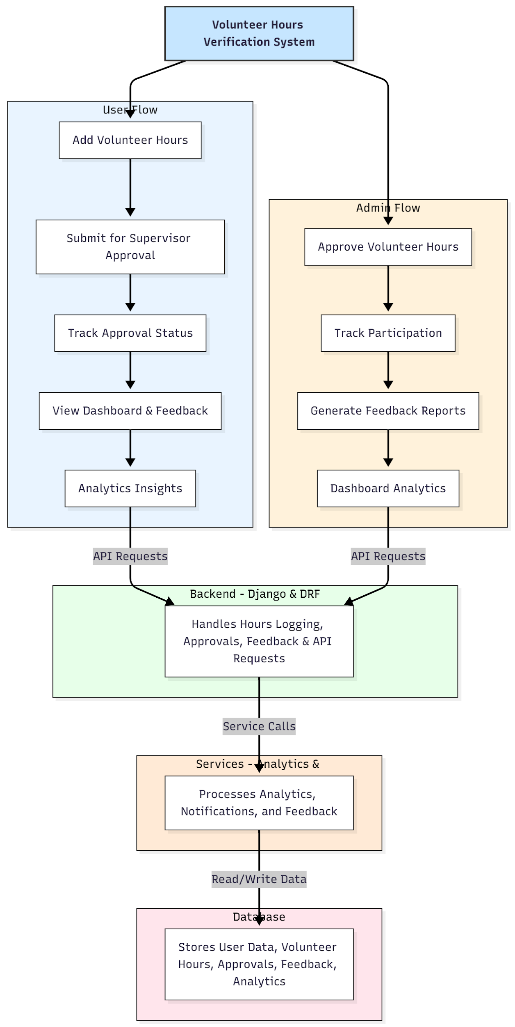

WORKING OF THE PROJECT:
Volunteers log their hours into the system and submit them for supervisor approval. The backend validates entries, records them securely, and updates the status. Supervisors review submissions and approve or reject hours, while feedback can be added for each volunteer. Administrators can monitor overall participation, generate dashboard analytics, and prepare feedback reports. Services handle notifications, analytics, and feedback processing, while the database stores all records securely, enabling efficient and transparent volunteer hour management..

SOFTWARE REQUIREMENT:
- Backend:
  - Python 3.x
  - Django
  - Django REST Framework
  - SQLite/PostgreSQL
- Frontend:
  - Node.js and npm
  - React.js
  - Axios
- Development Tools:
  - Visual Studio Code
  - Postman (for testing APIs)
  - Git/GitHub (for version control)
- Server/Deployment (Optional):
  - Gunicorn, Nginx, or Heroku/AWS for hosting

ADVANTAGES OF THE PROJECT:

• Streamlines volunteer hour submission and approval
• Provides accurate tracking of volunteer participation
• Enhances accountability through supervisor sign-off
• Generates dashboard analytics for users and admins
• Facilitates feedback reporting and performance tracking
• Reduces administrative workload and manual errors
• Improves volunteer engagement and transparency
• Supports secure and scalable operations

APPLICATIONS OF THE PROJECT:
• NGOs and nonprofit organizations
• Student internship tracking
• University clubs and community service programs
• Corporate social responsibility programs
• Volunteer-driven events and campaigns

REFERENCES:

- Django REST Framework Documentation — Django Software Foundation. Django Documentation. Available: https://docs.djangoproject.com/
- Django REST Framework. DRF Documentation. Available: https://www.django-rest-framework.org/
- React. React Official Documentation. Available: https://reactjs.org/docs/getting-started.html
- Redux. Redux Documentation. Available: https://redux.js.org/introduction/getting-started
- PostgreSQL Global Development Group. PostgreSQL Documentation. Available: https://www.postgresql.org/docs/
- MySQL. MySQL Reference Manual. Available: https://dev.mysql.com/doc/
- Git. Git Documentation. Available: https://git-scm.com/doc
- Node.js. Node.js Documentation. Available: https://nodejs.org/en/docs/
- Axios. Axios Documentation. Available: https://axios-http.com/docs/intro
- Socket.io Documentation – https://socket.io/docs/

